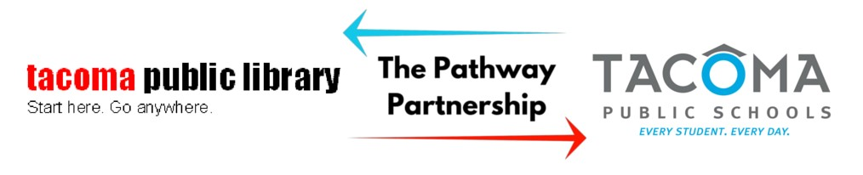



**Pathway Opt-Out Form**

Dear Parents/Guardian,

Tacoma Public Schools and Tacoma Public Library have a district-wide partnership to offer **the Pathway Partnership Program**, a new way for every TPS student, preK-12, to access resources of the public library system. Pathway allows TPS student IDs to also serve as a Tacoma Public Library card.

Through the Pathway Program, **TPS Student IDs** will allow them to…

* Borrow 5 items from any **Tacoma Public Library** location.
  + Including: Books, Periodicals, Audiobooks, CDs and DVDs
* Incur **No overdue fines or fees** for items checked out with a TPS student ID
* Borrow up to 20 digital items (ebooks or audiobooks) through the **Tacoma Public Library** website and Sora (OneDrive) and Libby, a digital media provider.
* Use computers with internet access at any of the 8 library locations and online access to educational resources for school
* Receive free on-line, one-on-one homework tutoring in English and Spanish for a variety of subjects
* Weekly $5 print credit

For more information go to [https://www.tacomalibrary.org/pathway-partnership/.](https://www.tacomalibrary.org/pathway-partnership/)

What student information will Tacoma Public Schools share with Tacoma Public Library? Student's

Name, School Building Name, Grade Level, and Student ID number. No other information will be shared.

**Privacy:** To accommodate families with privacy concerns, parents/guardians can complete the form below allowing TPS to share the above information with **Tacoma Public Library only.** This accommodation allows families the privacy requested but enables enrollment in Pathway. To opt in to Pathway, please complete the below form.

**\*Please note, by allowing your child to participate in Pathway Program, you agree to accept responsibility for monitoring their usage.**

**If you would not like your child to participate in Pathway Partnership Program** please print, complete and return this parent opt-out form to your child’s Teacher-Librarian. You may also email the form.

Child’s Name (Print)_______________________________________________________________________________

School_____________________________________________________________ Grade____________________

Parent or Guardian’s Name (Print) ___________________________________________________________________

By signing this form, I understand my child will **not** participate in the Pathway Partnership Program.

Parent/Guardian (Signature):______________________________________ Date ____________